OXFORD CITY COUNCIL

ANTI-SOCIAL BEHAVIOUR, CRIME AND POLICING ACT 2014

PART 4, SECTION 59

PUBLIC SPACES PROTECTION ORDER

Oxford City Council (the Council) in exercise of the power under section 59 of The Anti-Social Behaviour, Crime and Policing Act 2014 (the Act), being satisfied that the conditions set out in section 59 of the Act have been met, makes the following order:

- The Order applies to the public areas shown delineated by the black line on the plan annexed to this Order (the Restricted Area):

- No person shall aggressively beg. Aggressive begging includes begging near a cash machine or begging in a manner reasonably perceived to be intimidation or aggressive.

- No person shall remain in a public toilet without reasonable excuse.

- No person shall urinate or defecate in a public place. This includes the doorway or alcove of any premises to which the public has access.

- No person shall cycle within Queen Street or Cornmarket Street outside the permitted cycling times of 6 p.m. to 10 a.m.
- No person shall perform any type of street entertainment that causes a nuisance to nearby premises or members of the public. This includes obstructing the highway or shop entrances, or using street furniture including public seats, lamp posts and railings.

- No person trading as a pedlar shall:
- remain in any location for more than 10 minutes unless it is to complete a transaction
- locate themselves within 50 metres of their previous location
- return to any location already occupied in the last three hours
- obstruct the highway or shop entrances

- No person shall refuse to stop drinking alcohol or hand over any containers (sealed or unsealed) which are believed to contain alcohol, when required, to do so by an authorised officer in order to prevent public nuisance or disorder.

- Any person in charge of a dog within the restricted area shall be in breach of this Order if he/she:

- fails to keep the dog on a lead and under physical control at all times

- is found to be in charge of more than four dogs whilst in a public place

- allows the dog to foul in a public place and then fails to remove the waste and dispose of it in an appropriate receptacle

- allows the dog to enter any covered public space

The provisions of this order relating to the control of dogs shall not apply to any person who is registered blind in accordance with section 29 of The National Assistance Act 1948, to any person who is deaf and in charge of a dog trained by Hearing Dogs for Deaf People and to any person suffering a disability and in charge of a dog trained to assist with his/her mobility, manual dexterity, physical coordination or ability to lift and carry everyday objects and the said dog has been trained by a prescribed charity.

- Any person who, without reasonable excuse, fails to comply with the requirements of this Order commits an offence and shall be liable, on summary conviction, to a fine not exceeding level 3 on the standard scale.

- This Order shall come into force on ……………………… and remain in place for a period of three years.

Dated | 2015
Signed
………………………………………………………

SCHEDULE
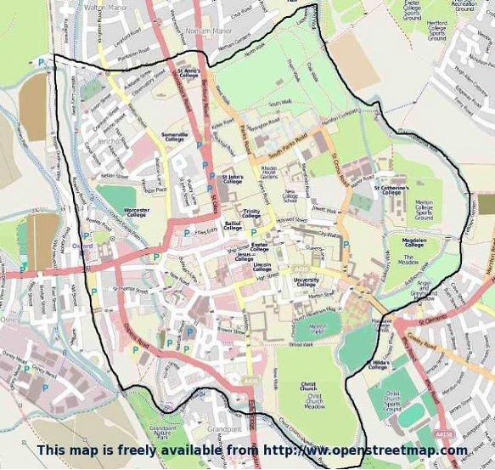

CHALLENGING THE VALIDITY OF ORDERS
An interested person may apply to the High Court to question the validity of—
- This Order, or
- A future variation of this Order.
“Interested person” means an individual who lives in the restricted area or who regularly works in or visits that area.
An appeal against this Order or a future variation of this Order may be made to the High Court within six weeks from the date on which the order or variation is made, on the grounds that:

- Oxford City Council did not have power to make the order or variation, or to include particular prohibitions or requirements imposed by the order (or by the order as varied);
- a requirement under Chapter 2 of the Anti-Social Behaviour, Crime and Policing Act 2014 was not complied with in relation to the order or variation.

